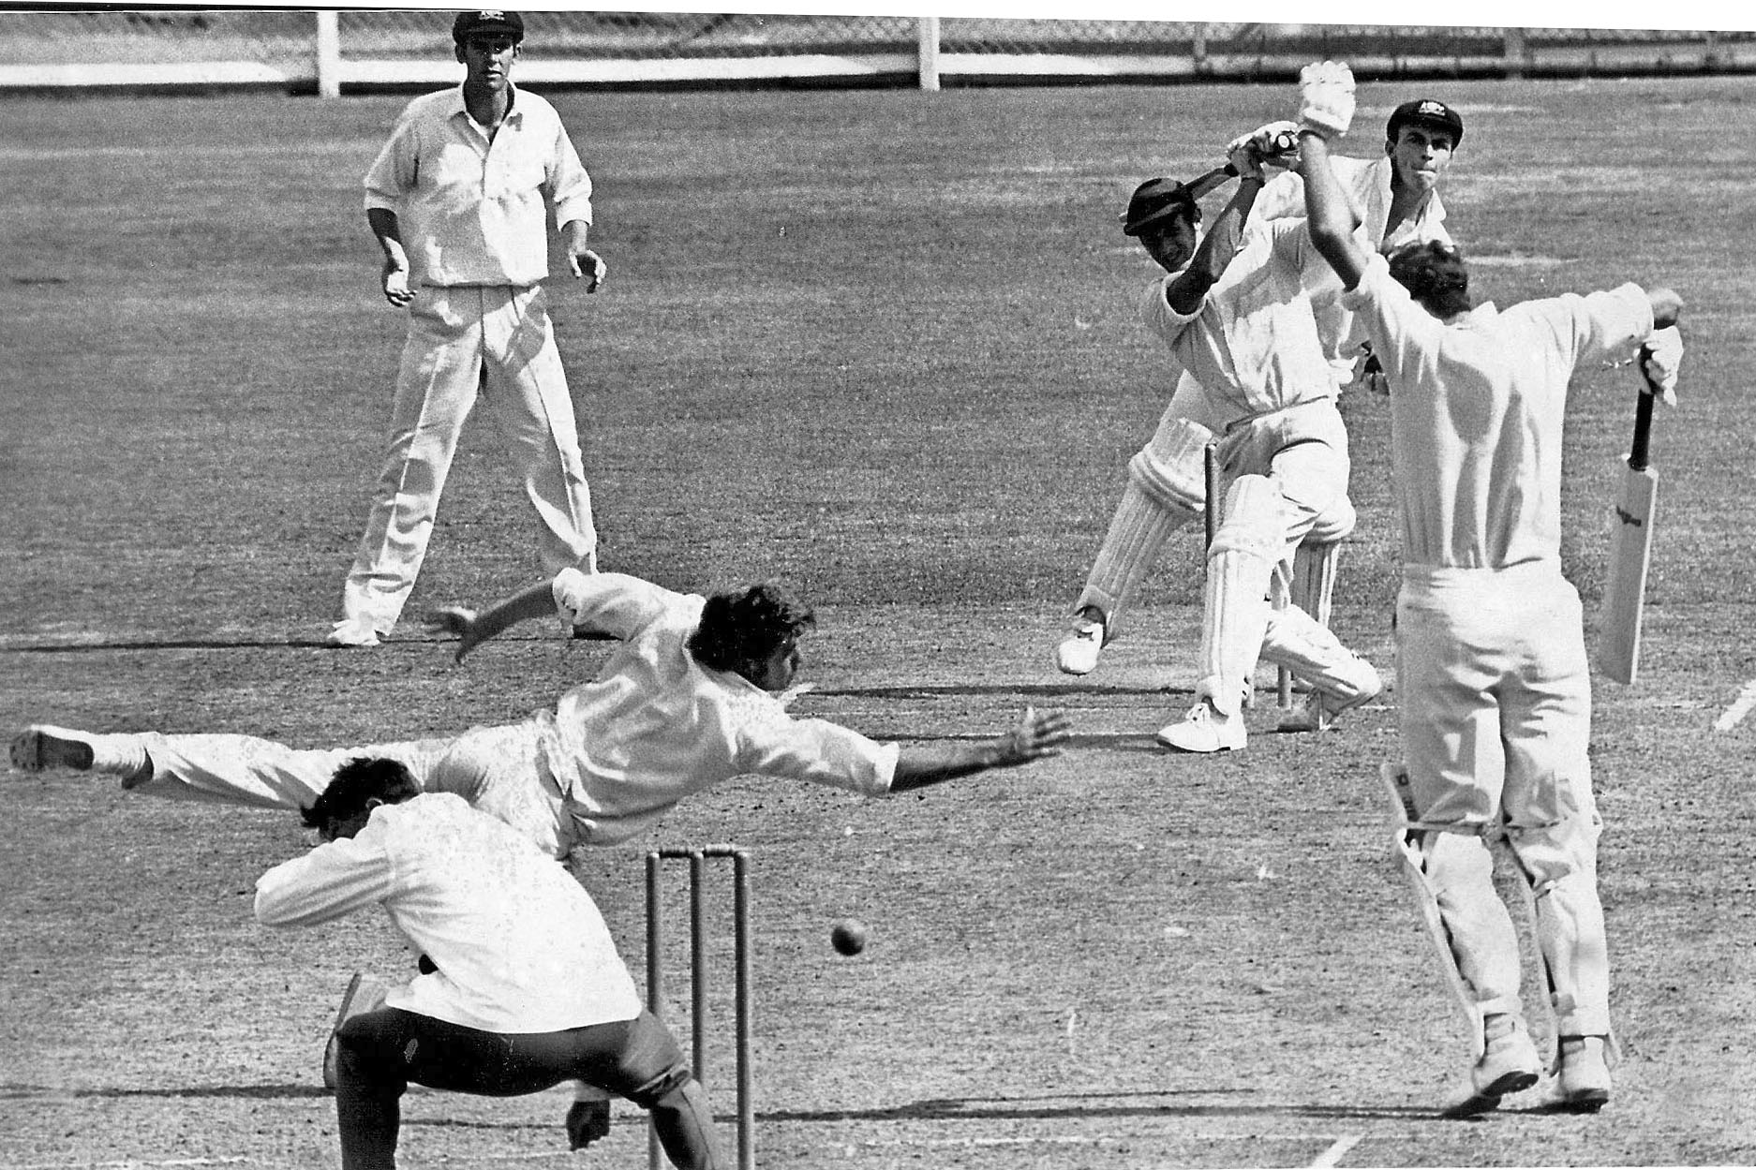

**Dayle Hadlee drives Dave Renneberg for two runs. Bruce Taylor avoids the ball.**

**21 February 1970 Lancaster Park**

**Australia 233 and 266/5declared Canterbury 270 and 117/6. Match drawn**